Surge WorkFlow Doc

* We got StarDist Pre-trained model that has detect edges

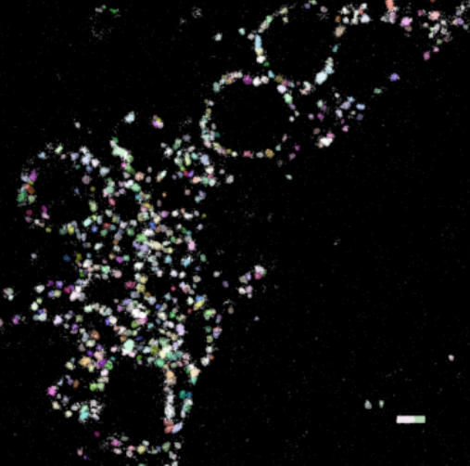

* Plotting those detected circle on the original image.

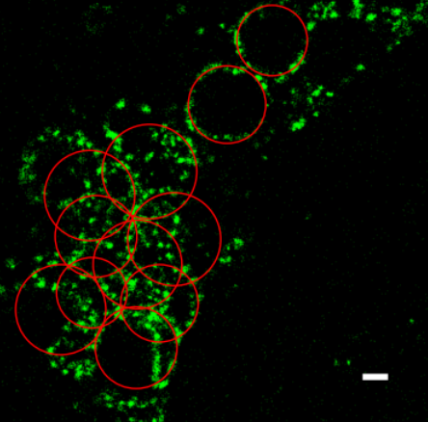

* Used Hough Circle Transform to detect circular mitochondria.
* We used ImageJ software for initial image pre-processing.

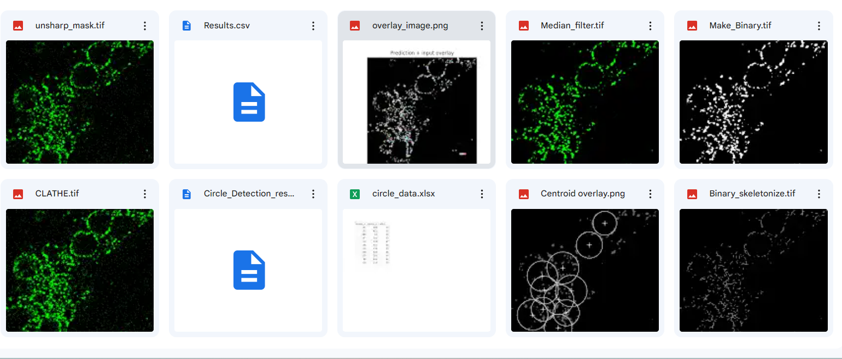

* For each image we augmented 45-45 images.

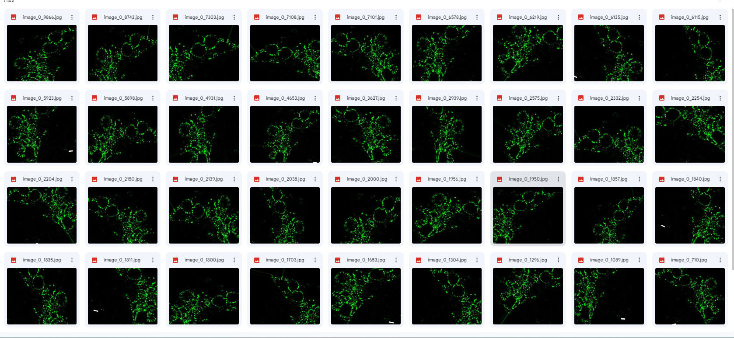

* Since our dataset has only two images therefore we increased our dataset with data augmentation.